 | Animals everywhere  2. The tiger | 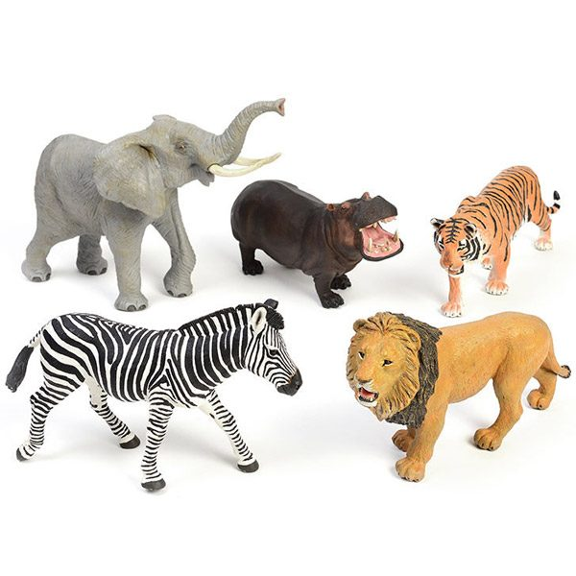
1. Read and match.

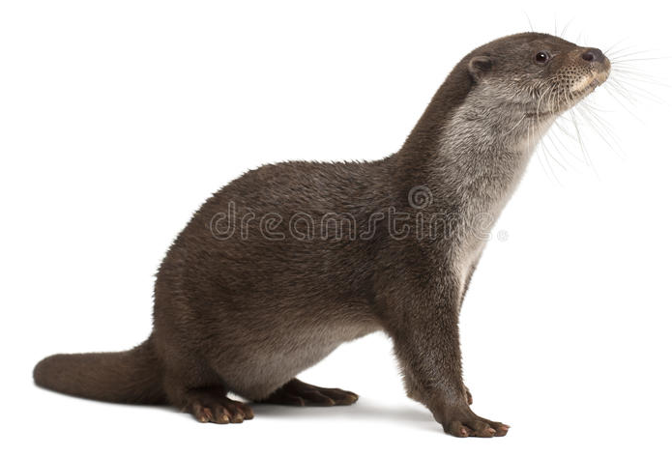
1. Does the otter eat fish? Yes, it plays with table tennis balls.
2. Does it live in the water? No, but it runs a lot.
3. Does it climb trees? Yes, but it doesn’t eat plants.
4. Does it play with balls? No, it lives on land.

2. Write the questions. Then answer.
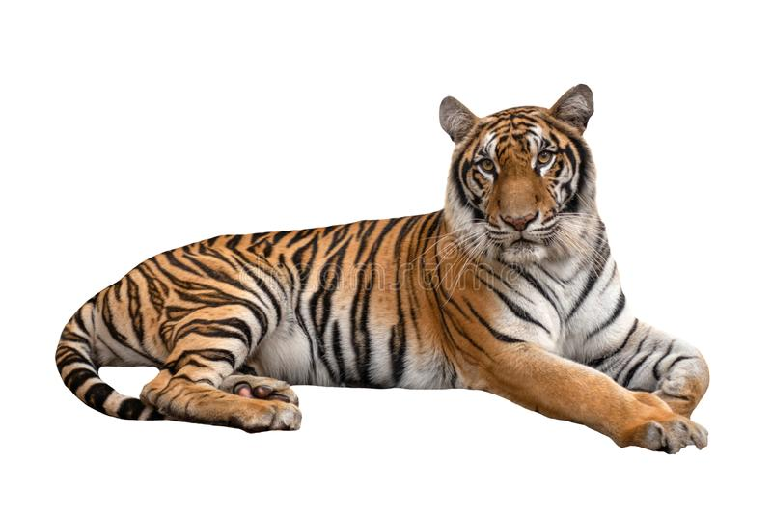

1. tiger ? Does fish this eat
............................................................................. .............................................. X

2. fly it Does and ? climb
........................................................................... ............................................. X

3. Does run ? hunt and it
............................................................................ ............................................. V
4. live it ? Does water in
. ........................................................................... ............................................. X

