Forum permissions
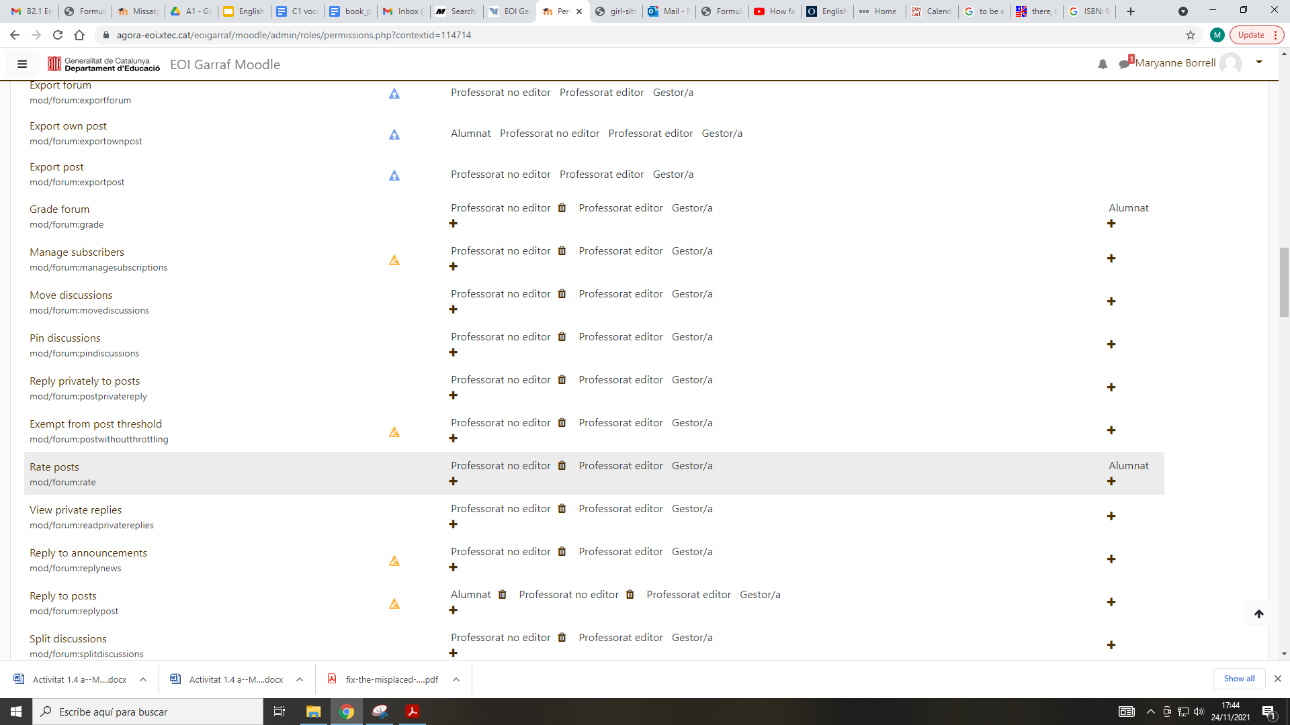
Override permissions
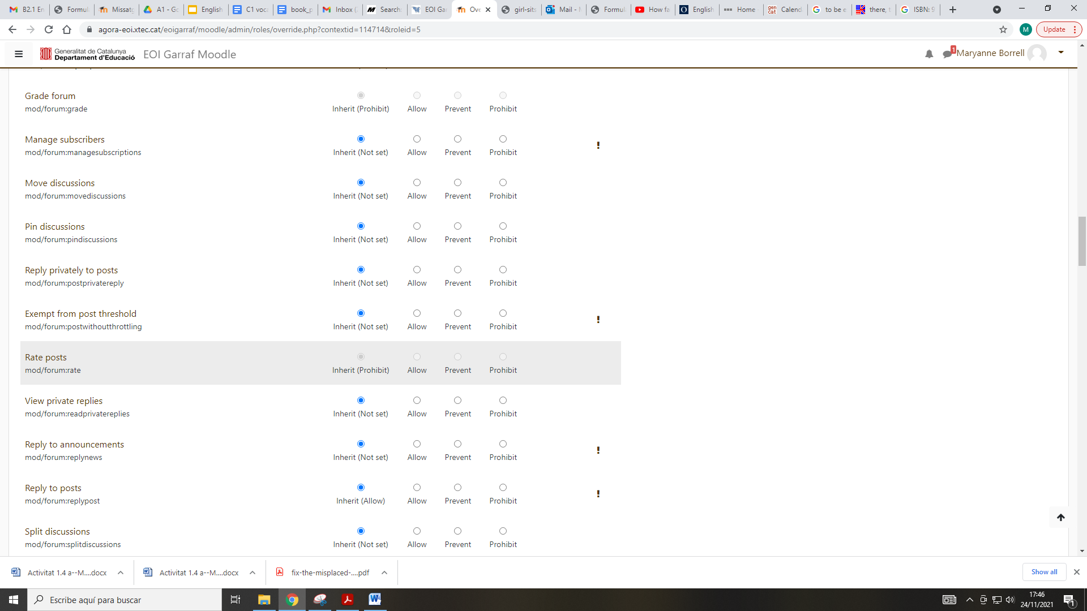
Basically, by mistake I prohibited students from rating post entries, and now it won’t let me change anything.
I’d like students to be able to rate and /or like other students’ forum entries.

Thanks!

