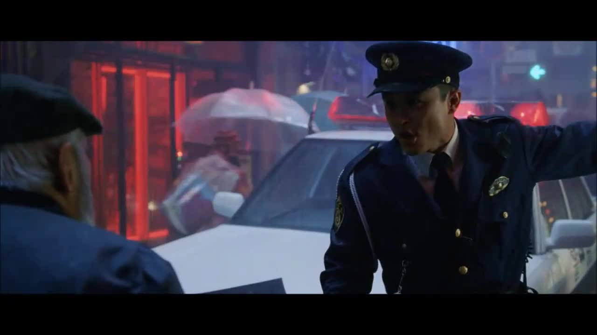
Past perfect and past perfect continuous
The Day after Tomorrow – Tokyo Hailstorm
https://www.youtube.com/watch?v=O5Gfw63Yl6c

- Preparation/discussion

Do you like disaster movies? Why/why not?
Why do you think disaster movies are so popular?
Do disaster movies serve any practical purpose?

- Watch the segment and identify the order of the actions below.

People have umbrellas up.
The man walks away from the café.
A police car is driving around giving information.
The policeman is hit on the head by a hailstone.
The man puts his case on his head for protection.
A man stops at a street side cafe and drinks some tea.
The man is talking on his phone.
The café owner closes his café up.
The man’s telephone rings.
Everyone starts running around screaming.
A hailstone hits the man and he falls down.
The policeman is arguing with an old man.
A motorbike drives into a shop window.

Consider which of these actions had finished when the hailstorm hit and which of these actions were taking place during the hailstorm. Some of the actions may have been continuing throughout the clip.

- Fill in the blanks with the past perfect or the past perfect continuous form of the verbs in parentheses. Consider carefully whether the first action was completed or taking place when the second action happened.

A man _____________ (drink) tea at a street side café when his telephone rang.
The man __________ (already, walk) away from the café when the first hailstone hit.
The café owner ___________(close) up his café before the hailstorm.
The policeman ___________(argue) with a man when the hailstone hit him on the head.
People ______________(walk) around with umbrellas before the hailstorm hit.
A man ________________(ride) a motorbike during the hailstorm but then crashed into a shop window.
The man _____________(put) his case on his head for protection but still got hit.

- Extension activity – read the article and reflect, referring back to the questions in section A.

Disaster
We are living, it seems, in the golden age of the disaster movie. We may call them monster movies or action movies, superhero blockbusters or ancient epics, but let's face it: they're all disaster movies in fancy dress. Whichever genre you think you're paying for, it's harder and harder to find any big-budget Hollywood entertainment that doesn't include the demolition of a major conurbation, and a body count in the tens of thousands.


If you were to look on the bright side, you could argue that we simply enjoy seeing things being blown to smithereens. "There's a kind of pleasure in destruction," says Sheldon Hall, co-author of Epics, Spectacles and Blockbusters: A Hollywood History. "It's the kind you get from building a sandcastle and then jumping on it as a child. When we watch those elaborate sets blow up in a James Bond film, we know that they're fake, so we appreciate the skill that goes into building them, and the same sort of skill that goes into their destruction. It's all part of the magic of the movies."
But it can't be a coincidence that the images in our multiplexes are so similar to those on the news, whether we're watching footage of Hurricane Katrina, the Indian Ocean tsunami or the latest terrorist bombing. In these chaotic times, is it any wonder that we're drawn to films that reframe that chaos as an awfully big adventure?
"All around the world, people are aware of climate change," says Kramer, "That could underpin our sensitivity to stories that respond to such concerns. Let's not forget that Avatar came out on the very weekend that the UN's climate change conference in Copenhagen ended in failure. Avatar was probably consumed by more people in a short space of time than any other story in human history – and it was all about a military-industrial complex intent on ruining a planet."
That's all very well, but apart from making James Cameron even richer, do these mega-disaster movies have any practical purpose? Will Hollywood's doom-mongering prompt impressionable film-goers to change their ways? Well, possibly.
"One thing that a lot of these films have in common is the sense that the threat is not just to me and my family, but to everybody," says Kramer. "They tend to tell stories about isolated groups overcoming their differences to come together and solve their problems. And because these films reach different communities around the planet, they might just foster a sense of solidarity and prepare the ground for some sort of collective action in the future. They reach into us and respond to a need that we have – a hope that if we get together, we can make a difference.
A man had been drinking at a street side café when his telephone rang.
The man had already walked away from the café when the first hailstone hit.
The café owner had closed up his café before the hailstorm.
The policeman had been arguing with a man when the hailstone hit him on the head.
People had been walking around with umbrellas before the hailstorm hit.
A man had been riding a motorbike during the hailstorm but then crashed into a shop window.
The man had put his case on his head for protection but still got hit.

