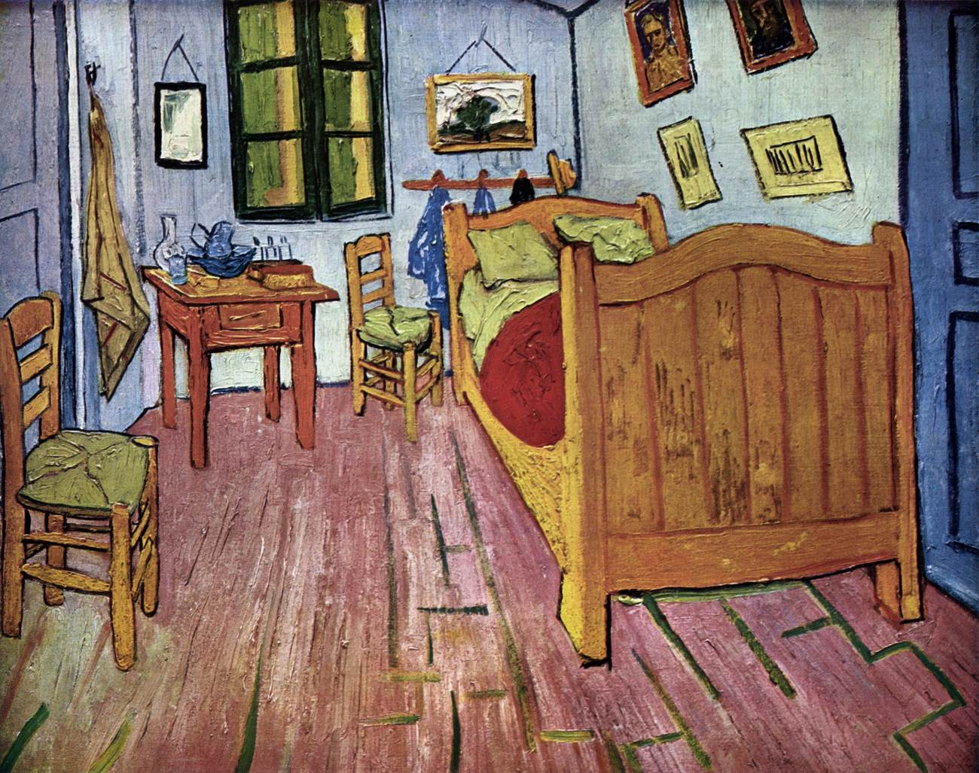

GOGH, Vincent van
Vincent's Bedroom in Arles
October 1888, Arles
Oil on canvas, 72 x 90 cm
Rijksmuseum Vincent van Gogh, Amsterdam

