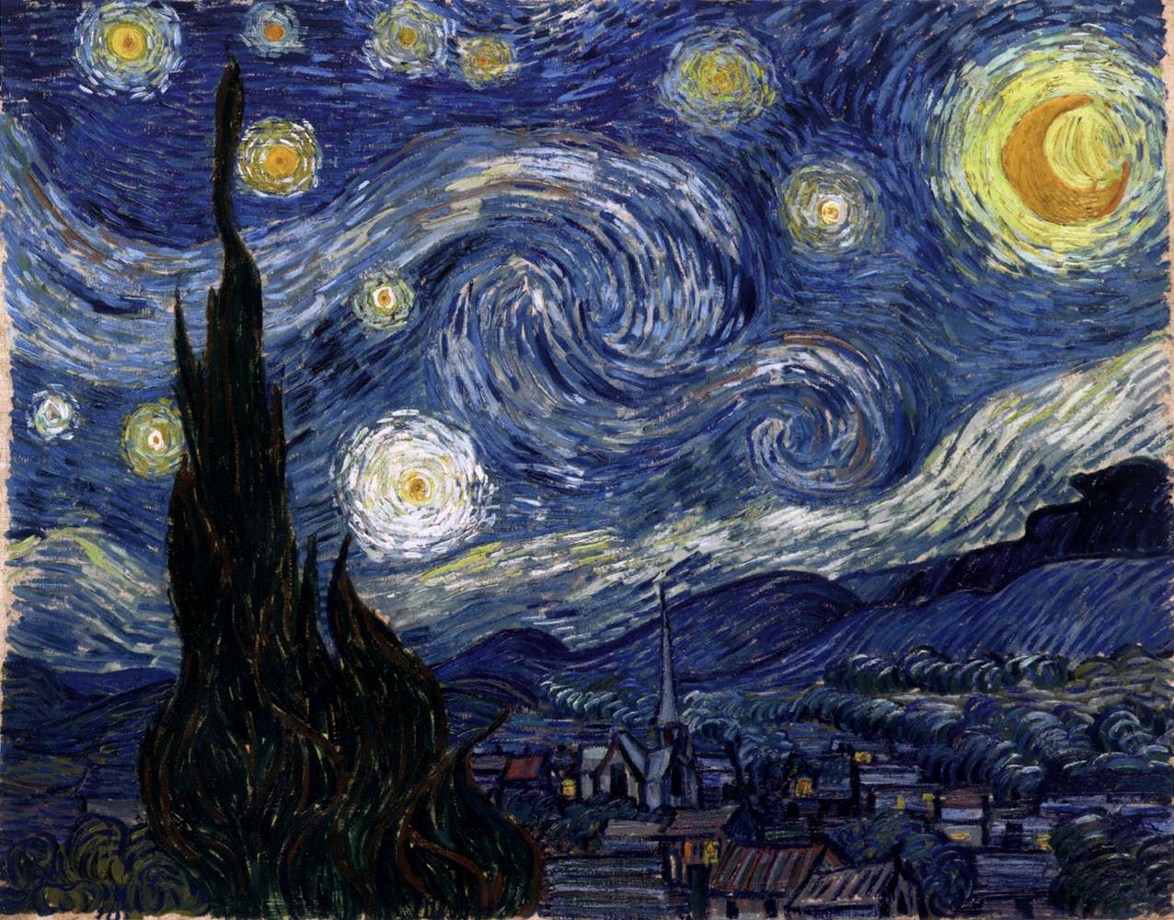
GOGH, Vincent van
Starry Night
June 1889, Saint-Rémy
Oil on canvas, 74 x 92 cm
Museum of Modern Art, New York

