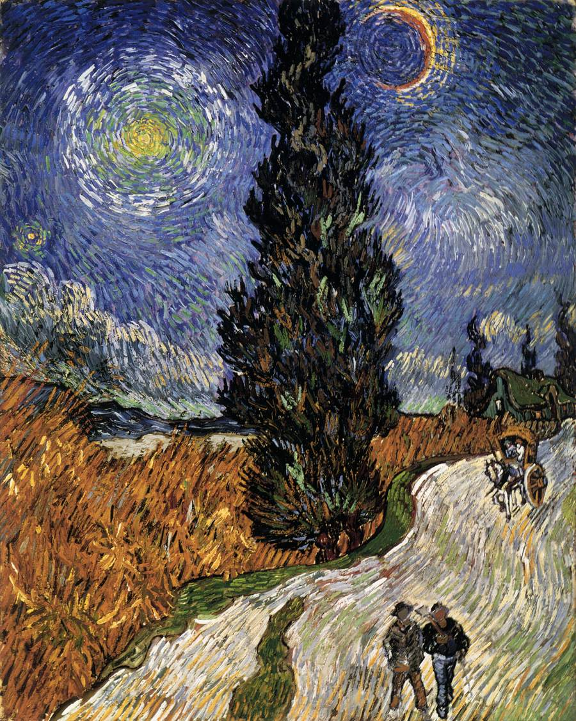

GOGH, Vincent van
Road with Cypress and a Star
May 1890, Auvers-sur-Oise

