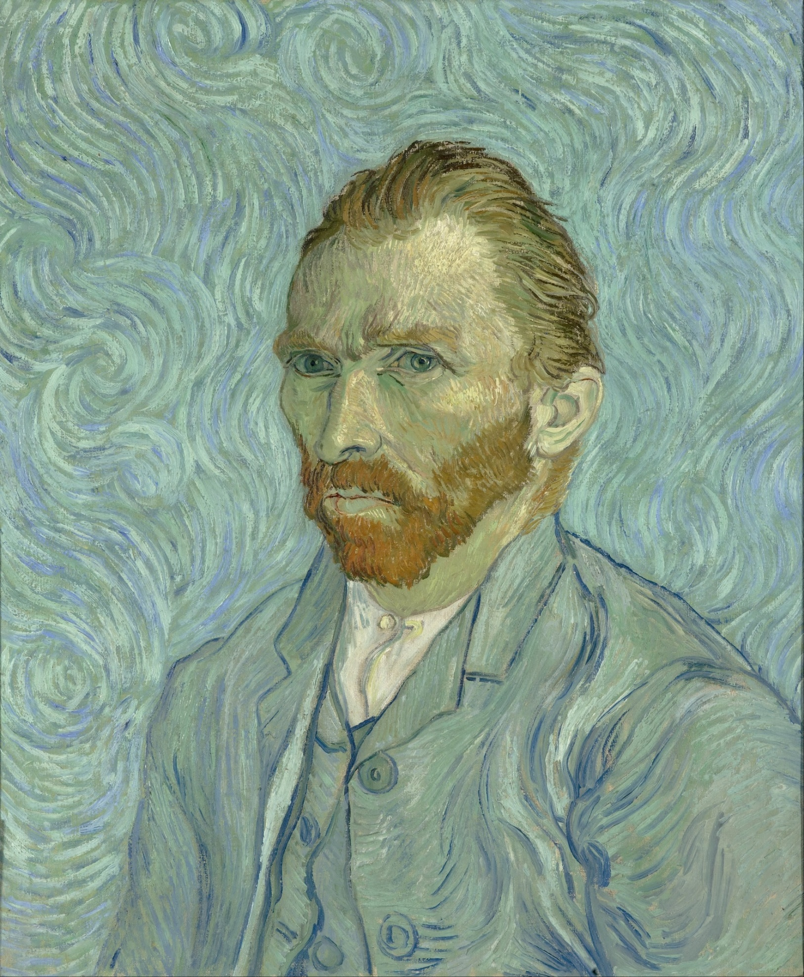

GOGH, Vincent van
Self-Portrait
September 1889, Saint-Rémy
Oil on canvas, 65 x 54 cm
Musée d'Orsay, Paris

