Before watching

Answer the following questions.
- What’s the name of this bridge?
..........................................................................

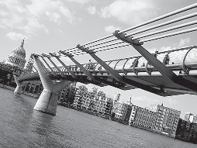

- What’s the name of the big building at the end of the bridge?
..........................................................................

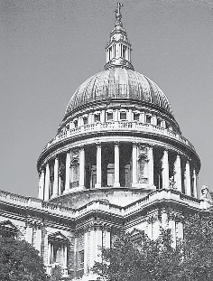

- What’s the name of this bridge?
..........................................................................

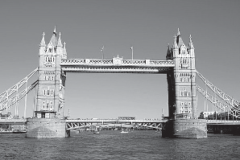

Video vocabulary. Match the English words with the right definition.

  - wheel  a. a famous or notable place
  - capsule  b. a round object that helps cars to move
  - tower  c. another word for “soldier”
  - fire  d. a structure that lets people and cars cross a river
  - landmark  e. a person from another place / country
  - bridge  f. when things burn and are damaged
  - outsider  g. to attack and occupy another country
  - troop  h. a glass or plastic container
  - heritage  i. a tall structure, often near a church
10. invade  j. the preservation of important buildings / artwork from the past

While watching

Number these places in the order you see them on the video.
- a. Docklands
- b. Houses of Parliament
- c. Millennium Wheel
- d. Pall Mall
- e. St Paul’s
- f. Trafalgar Square
- g. Buckingham Palace
- h. Shakespeare’s Globe
- i. Westminster Abbey
- j. Covent Garden

Watch the video again and choose the correct alternative.
  - Big Ben is
    - a. a station
    - b. a clock
    - c. a parliament building.
  - Another name for the Palace of Westminster is
    - a. the London Eye
    - b. Houses of Parliament
    - c. Millennium House.

  - Shakespeare’s Globe is
    - a. the original building
    - b. a model building
    - c. a copy of the original.
  - The original London Bridge was built
    - a. by the Normans
    - b. by the Celts
    - c. by the Romans.
  - St Paul’s was rebuilt following
    - a. the Great Fire
    - b. the Roman invasion
    - c. The Second World War.
  - Covent Garden
    - a. is London’s main fruit and vegetable market
    - b. was the main fruit and vegetable market in the past
    - c. is now completely closed.

  - In the beginning Buckingham Palace
    - a. was a hotel
    - b. was created for the Royal Family
    - c. belonged to the Duke of Buckingham.
  - Nelson’s column commemorates
    - a. the Battle of Trafalgar
    - b. the Battle of Waterloo
    - c. the Battle of Britain in World War II.
  - On the London Eye, each capsule can hold
    - a. 25 people
    - b. 52 people
    - c. 15 people.
  - In the Docklands Area you can find
    - a. only offices
    - b. apartments and offices
    - c. only apartments.

