Welcome to Word
  - 6 tips for a simpler way to work

Quick access to commands
At the top of your document, the Quick Access Toolbar puts the commands you use frequently just one click away.
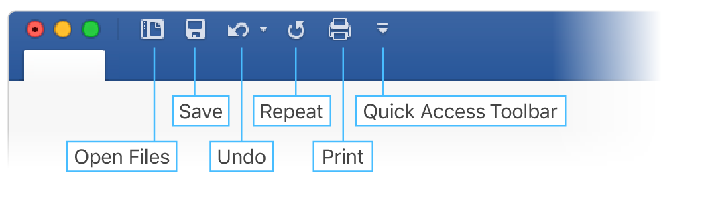
If the commands currently shown aren’t quite what you need, customize the Quick Access Toolbar.
Try it:
Select the Customize Quick Access Toolbar button and select command names to add or remove them from the Quick Access Toolbar.
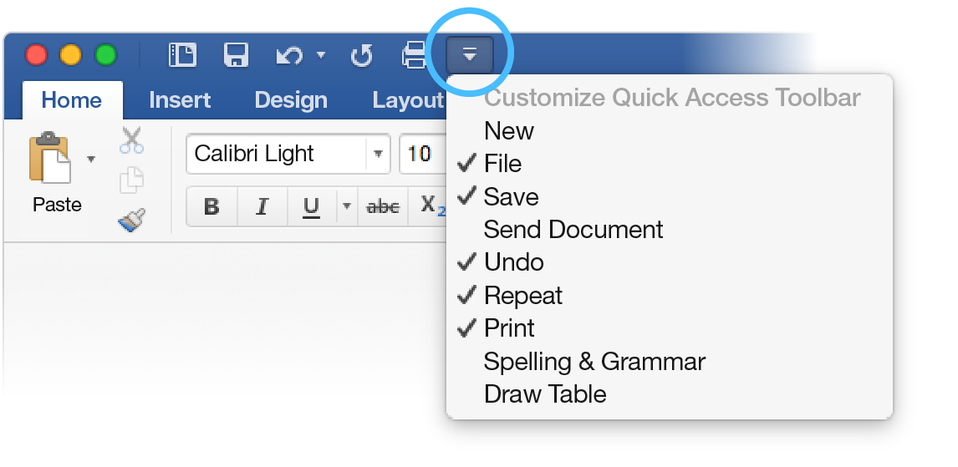

Look professional, your way
In this document, styles like Heading 1 and Title have been applied to text (Home tab, Styles gallery). That lets you quickly overhaul the look of the whole document.
Try it:
- On the Design tab, select the different Style Sets and watch the formatting change automatically.
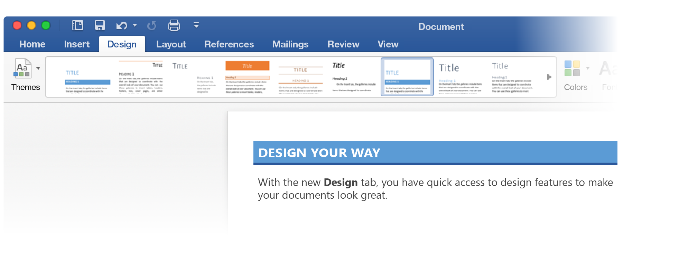
- Go to Themes and watch how colors and fonts change with the various choices.
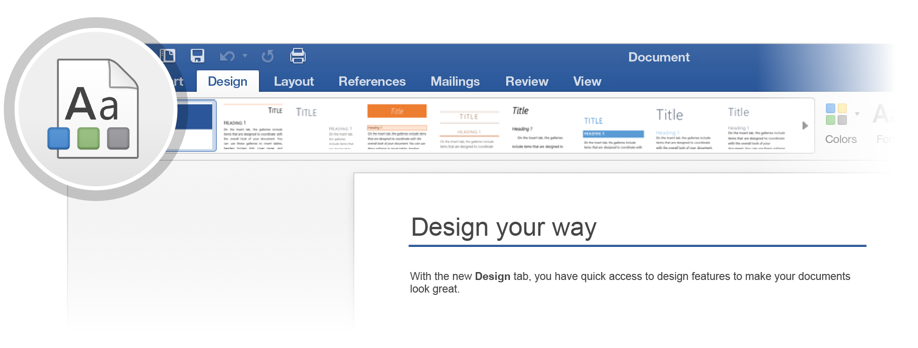
- The Design tab also provides choices for fine-tuning colors, fonts, or paragraph spacing. You can also add a watermark or page border, or change the color of the page.
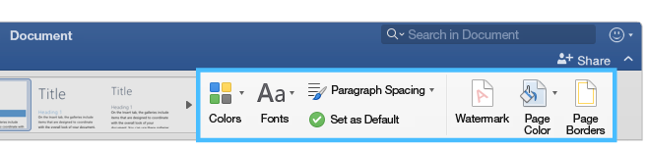

Edit pictures without leaving Word
When it comes to pictures, Word includes options for adjusting color, cropping, removing the background, applying artistic effects, and more.
Try it:
- Select this photograph of an otter:

- Select Picture Format tab, and then select Artistic Effects and select an effect, like Mosaic Bubbles.
- To see all the formatting options, select Picture Format tab, and then select Format Pane on the right side of the app.
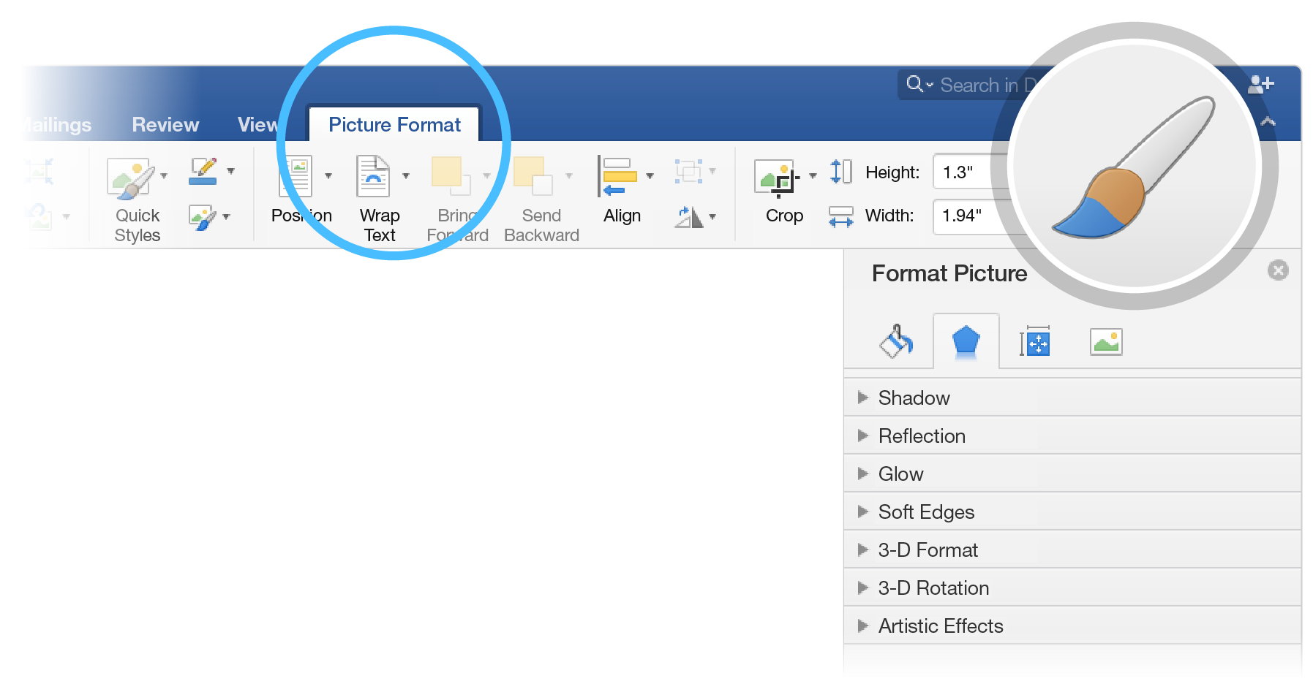
- If you apply formatting you don’t like, press F1 to undo it, or select Reset under Artistic Effects in the Format Pane to go back to the original picture.
Hint: To open the Format Pane quickly, press Command+Shift+1.

Explore without leaving your doc
Smart Lookup brings research from the web directly into Word.
Try it:
- Select the word “Otter”
- Go to the References tab and select Smart Lookup
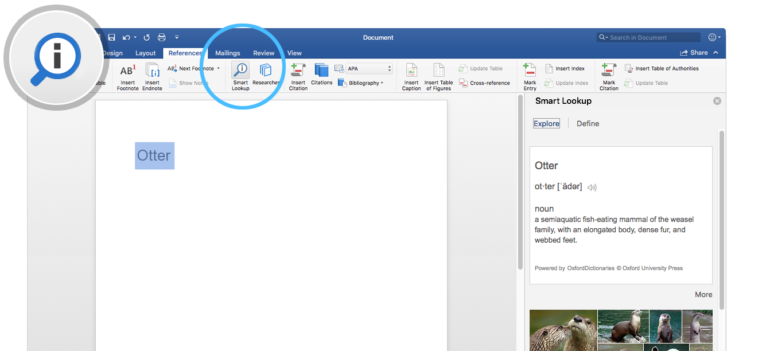
Source: Wikipedia CC-by-SA – https://en.wikipedia.org
- To close out of the Smart Lookup pane, select the Close button at the top of the pane.
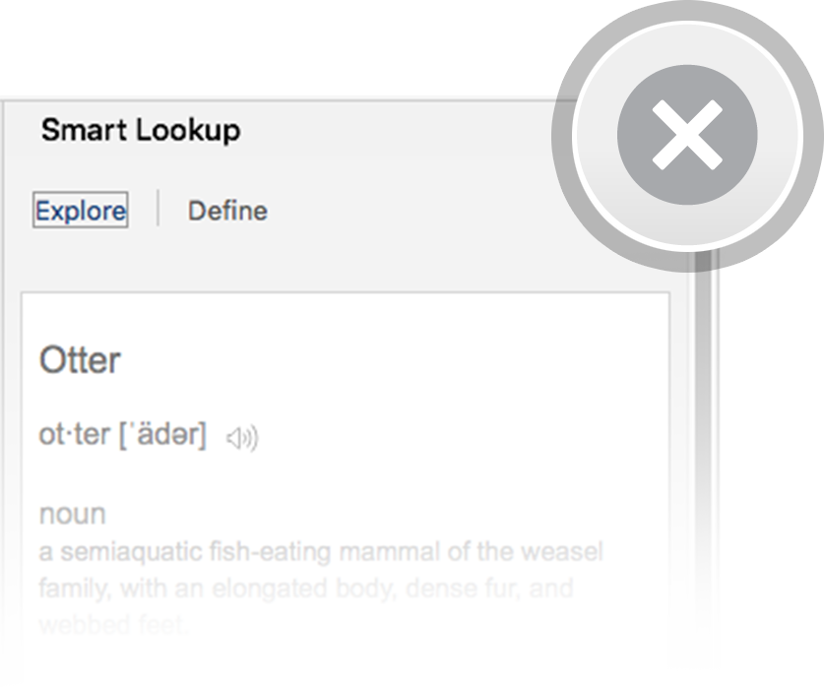

Designed for teamwork
With your document stored online, your group can work on it together at the same time.
How it works:
- Save your document in an online location, like OneDrive.
- Select Share button from above the ribbon.

- Invite people or send a link so they can edit with you.
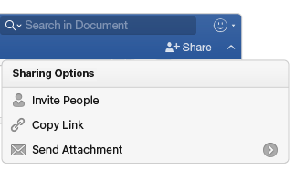

Give feedback in comments
Comments are threaded, so you can have a conversation right next to relevant text. This is a great way to quickly add your feedback.
Try it:
- Select somewhere in this paragraph, and then select the Review tab.
- Select New Comment, and type something.
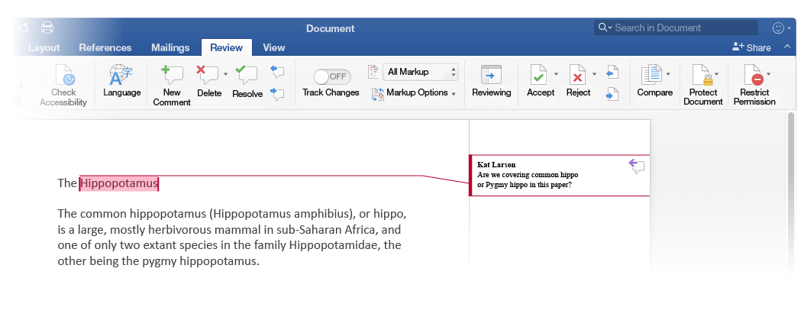
- Notice that your comment includes a Reply button. Use it to respond to a comment.

Hint: When you’ve taken care of feedback, get the comment out of your way without losing it: Select the comment and then select Done on the Review tab.

More questions about Word?
Visit the Word team blog. | 
Get help with Word for Mac.

