23rd April 2020 World Book Day
Happy Sant Jordi’s Day!

Every year on April 23rd millions of people around the world celebrate books and reading on ‘World Book Day’.
The date is important because two great writers died on this day in 1616; William Shakespeare, the English playwright and poet and Miguel de Cervantes, the Spanish writer.
Each year UNESCO (United Nations Educational, Scientific and Cultural Organization) chooses one city to be the World Book Capital City. This year the
city is Kuala Lumpur, in Malaysia.
So, what happens on this special day? Schools, book shops and libraries hold all kinds of fun events, wear costumes of their favourite book characters, authors sign copies of their books, story-tellers read to children and adults … and much more.
Have a look at the website to of the events for this year:
UNESCO World Book Capital 2020
https://en.unesco.org/commemorations/worldbookday
https://www.kualalumpurwbc.com/#top

1. Write about your favourite book. Use the model below.

My favourite book is Alice in Wonderland. The author’s name is Lewis Carroll. The plot is about a young girl who has lots of adventures. It’s exciting and funny. It isn’t boring or sad.
I like this book because there are lots of unusual characters.
I think it’s a good book for someone who likes imagining other worlds.
Star rating: ✪✪✪✪✪

TITLE:
My favourite book is…
The author’s name is
The plot is about …
It’s …
It isn’t …
I like this book because …
I think it’s a good book for someone who likes…
Star rating:

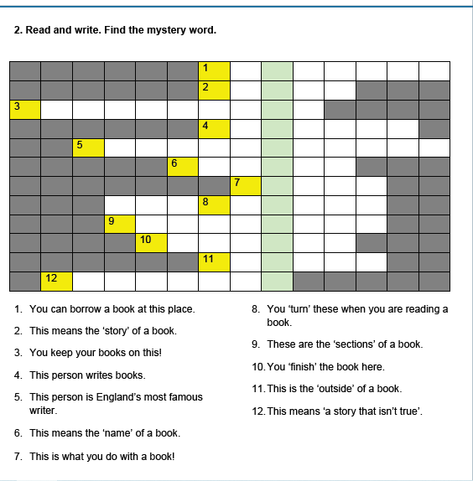
1. You can borrow a book at this place.
2. This means the ‘story’ of a book.
3. You keep your books on this!
4. This person writes books.
5. This person is England’s most famous
writer.
6. This means the ‘name’ of a book.
7. This is what you do with a book!
8. You ‘turn’ these when you are reading a
book.
9. These are the ‘sections’ of a book.
10. You ‘finish’ the book here.
11. This is the ‘outside’ of a book.
12. This means ‘a story that isn’t true’.

The mystery word is: _ _ _ _ _ _ _ _ _ _ _ _
3. Key to crossword:
1 library
2 plot
3 bookshelf
4 author
5 Shakespeare
6 title
7 read
8 pages
9 chapters
10 ending
11 cover
12 fiction

The mystery word is: illustration

