WHAT’S THE TIME?

NAME:
LEVEL:

Write the time and send your answers to the teacher (englishannatriola@gmail.com)

A 10:00

B 12:30

C 15:05

D 17:25

E 08:45

F 04:50

G 09:03

H 01:58

I 02:35

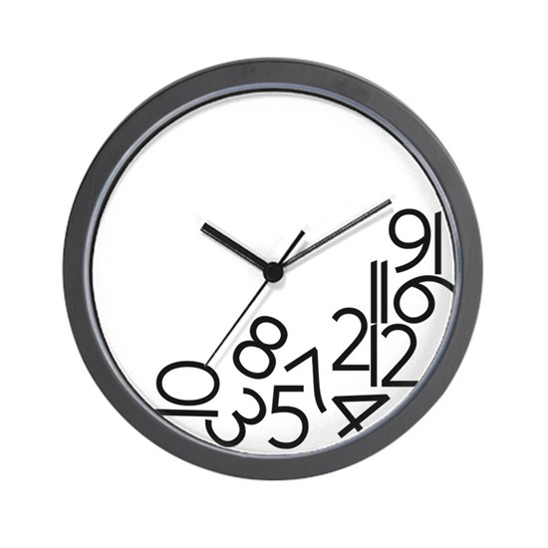
J 20:00

