**UNIT 6**

**ADVENTURE**

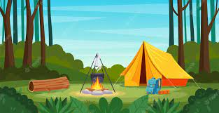

**Friday, 10th May,2024.**

**VOCABULARY**

1. **Watch the sunset **
2. **Explore some caves** 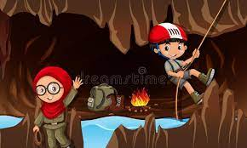
3. **Sleep in a tent** 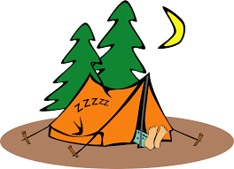
4. **Go sailing **
5. **Climb a hill **
6. **Visit a castle** 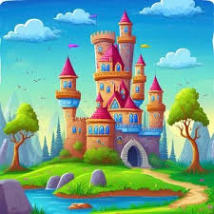
7. **Collect wood** 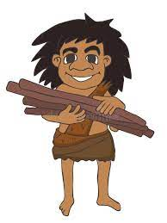
8. **Go hiking **
9. **Swim in a river** 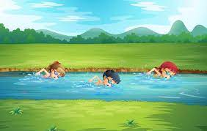
10. **Cook food in a campfire** 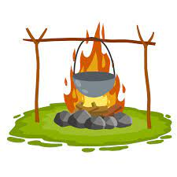

**Monday, 13th May,2024.**

**GRAMMAR**

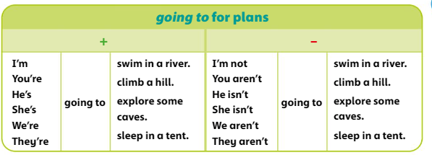

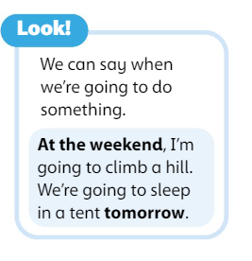

**Friday, 17th May,2024.**

**STORY'S VOCABULARY**

1. **Helmet** 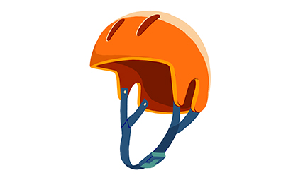
2. **Gloves **
3. **Zip wire** 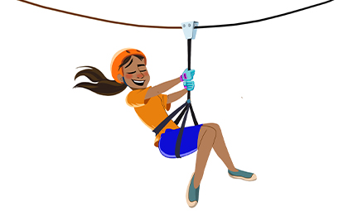
4. **Ladder** 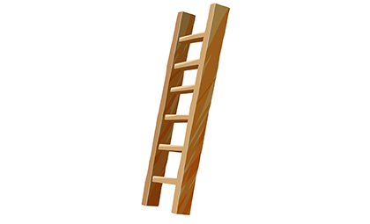
5. **Rope** 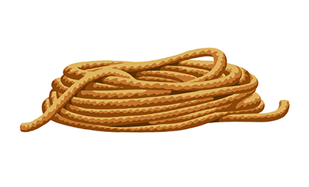
6. **Bridge **

**EXERCISE**

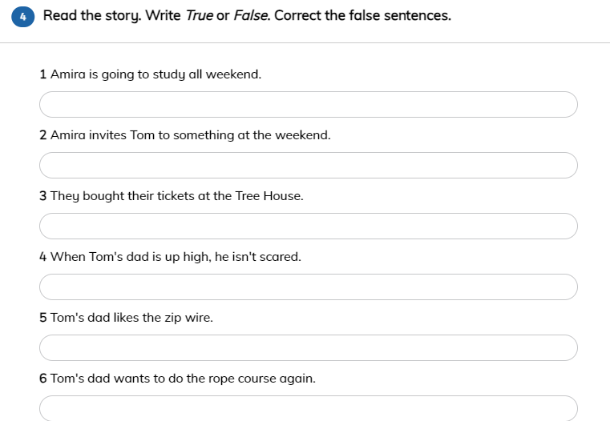

**Monday, 27th May,2024.**

**GRAMMAR**

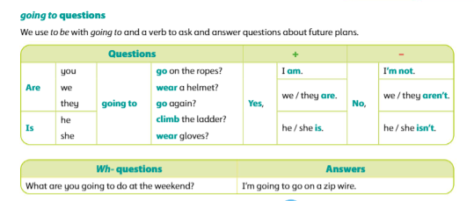

**EXERCISE**

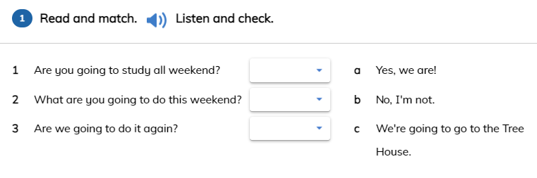

**Tuesday, 28th May,2024.**

**EXERCISE**

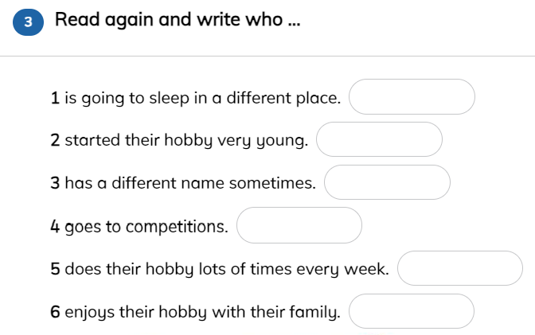

**Friday, 31st May,2024.**

**SONG**

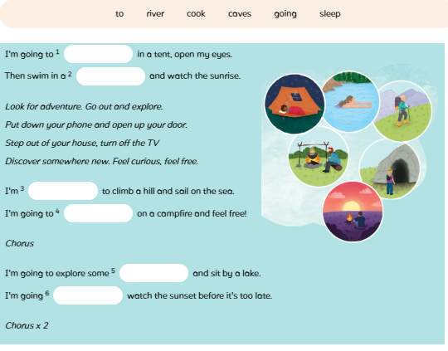

**Monday,3rd June,2024.**

**TEST UNIT 6**

**CB: P.58: vocabulary.**

**P.59: Grammar.**

**P. 62: Story’s vocabulary.**

**P.64: Story's grammar.**

**AB: P. 84-85: grammar.**

**Notebook**