HOMEWORK 4: INSTRUMENTS (writing)

DELIVERY DATE:
- 10th of May, 2020

ASSESSMENT CRITERIA:
- To write meaningful sentences and short texts through models. (Escriure frases amb sentit i textos curts a través de models)
- To show autonomy solving learning situations. (Mostrar autonomia resolent situacions d’aprenentatge)

NECESSARY MATERIALS:
- Device with internet connection.
- Paper and pencil.

1.- Look, copy and write.
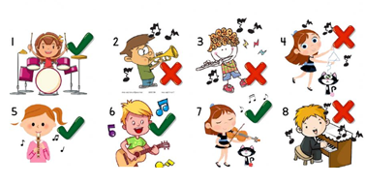
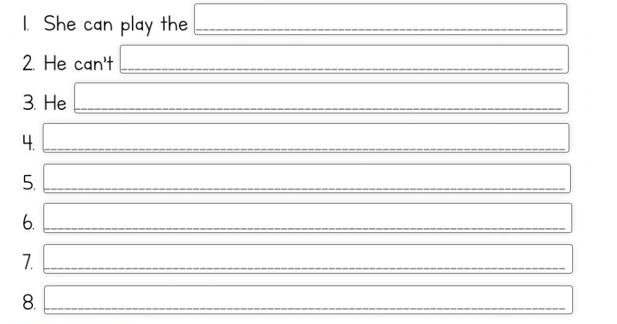

2.- After doing the activity you have to do this SELF-ASSESSMENT questionaire:
(Click on the picture or the link)
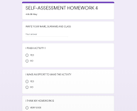
https://forms.gle/FhUsHXKASY9tuCD67
•Remember: This activity is to know your own learning. If you lie in the self-assesment you are lying to yourself.

ASSESSMENT

I’m going to grade this homework with this grid:

ACTIVITY | SATISFACTORY ACHIEVEMENT | NOTABLE ACHIEVEMENT | EXCELLENT ACHIEVEMENT
1.- Read and write. | You finish the activity  (3-4 answers OK). | You finish the activity  (5-6 answers OK). | You finish the activity  (7-8 answers OK).
SELF-ASSESSMENT | You complete the self-assessment sincereley, but with some help for the reading and the answer. | You complete the self-assessment sincerely with some help for the reading or the answer. | You complete the self-assessment in you own. Reading and answering sincerely.
*This is just information for you. You don’t have write nothing in the grid.

EXTRA-HOMEWORK

*If you want you can do this extra-activity.
This is not going to be graded, but you can improve your English with it.

►WHO’S DOING WHAT? Watch the video and tick  or cross X.
(click on the picture or the link)

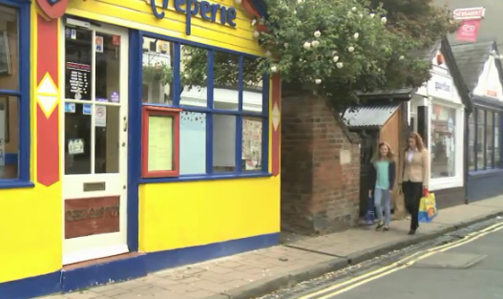
https://drive.google.com/file/d/1e1I00dqLUu6l7TbM4fnoq93I5agUg2oW/view?usp=sharing

 | Having a drink  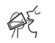 | Having a snack   | Playing chess   | Reading a comic  
Ellie
Luke
Adam
Mum

