HOMEWORK 7: DESCRIBING PEOPLE

In this homework we are going to learn how to describe people.

DELIVERY DATE:
- 31st of May, 2020

ASSESSMENT CRITERIA:
- To have the abilities and strategies to learn new vocabulary (memorisation, association, use of multimedia supports) in an individual way.
(Aconseguir les habilitats i estratègies per aprendre nou lèxic (repetició, memorització, associació, utilització de suports multimèdia) de forma individual.)
- To understand stories orally. (Comprendre oralment històries)
- To show autonomy solving learning situations. (Mostrar autonomia resolent situacions d’aprenentatge)

NECESSARY MATERIALS:
- Device with internet connection
- Paper, pencil and coloured pencils.

If you have any doubt you can contact me at msanc488@xtec.cat . (Si tens algún dubte pots contactar-me a msanc488@xtec.cat)

1.- Watch the video.
(Click on the picture or the link)
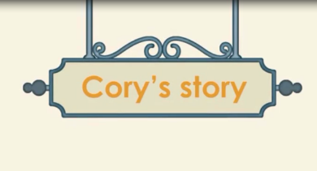
https://youtu.be/6qSWNnXClqo

2.- Complete the vocabulary chart. If you want to do it in a paper copy the word and draw it. (Completa la taula de Vocabulari. Si vols fer-ho en un paper copia les paraules i dibuixa-les)

WORD | PICTURE
1.- Young
2.- _______________ | 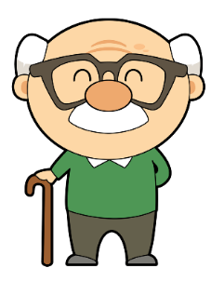
3.- Tall
4.- _______________ | 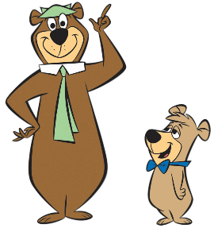
5.- Good- looking
6.- _______________ | 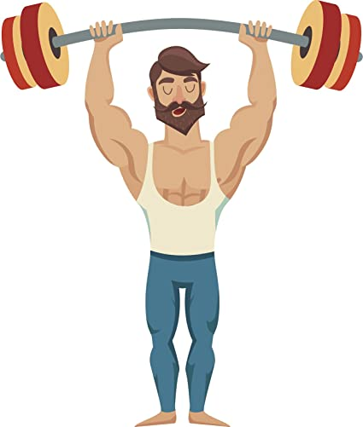

3.- After doing the activity you have to do this SELF-ASSESSMENT questionaire:
(Click on the picture or the link)
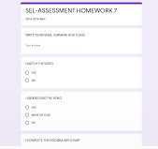
https://forms.gle/xgMEYNjf8R2ynhZS8

•Remember: This activity is to know your own learning. If you lie in the self-assessment you are lying to yourself.

ASSESSMENT

I’m going to grade this homework with this grid:

ACTIVITY | SATISFACTORY ACHIEVEMENT | NOTABLE ACHIEVEMENT | EXCELLENT ACHIEVEMENT
Vocabulary. | You write and draw the vocabulary. | You write, draw and colour the vocabulary (or complete the chart) | You write, draw and colour the vocabulary (or complete the chart) with a good presentation.
SELF-ASSESSMENT | You complete the self-assessment sincereley, but with some help for the reading and the answer. | You complete the self-assessment sincerely with some help for the reading or the answer. | You complete the self-assessment in you own. Reading and answering sincerely.
*This is just information for you. You don’t have to write nothing in the grid.

EXTRA-HOMEWORK
*If you want you can do this extra-activity.
This is not going to be graded, but you can improve your English with it.

►DO YOU REMEMBER CORY’S STORY? Answer the questions:
*If you make it in a paper, just copy the number and the correct answer (Si ho fas en un paper, només copia el número i la resposta correcta).

1.- Where are Ruby, Dylan and Cory?
a) They’re at the café.
b) They’re at the cinema.
c) They’re at the library.
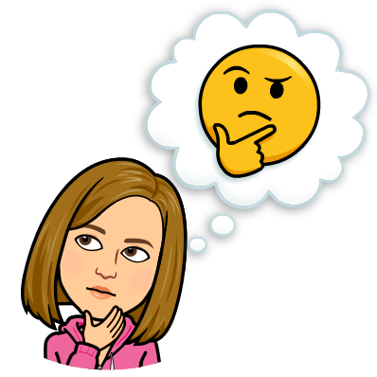
2.- Where’s Cinderella?
a) She’s at the farm.
b) She’s by the river.
c) She’s on the hill.

3.- Is the prince good-looking?
a) Yes, he is
b) No, he isn’t

4.- Is the prince short?
a) Yes, he is
b) No, he isn’t
6.- Who’s the frog?
a) The King
b) Cinderella
c) The prince

5.- What does the prince look like?
a) He’s got dark hair and Brown eyes.
b) He’s got blonde hair and blue eyes.
c) He’s got dark hair and blue eyes.

