ÍTEMS | YES | 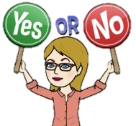  NO
I write the title.
The information is organised.
The information is presented in a clear and interesting way.
I write the purpose of my travel planner.
My travel planner gives information about destination, budget, activities to do, map and places to visit.
I use pictures or drafts in my travel planner.
Layout and colours are pleasant to the eye.
Observations:

